IBM CSP July Town Hall

Post Copy - Social Tiles

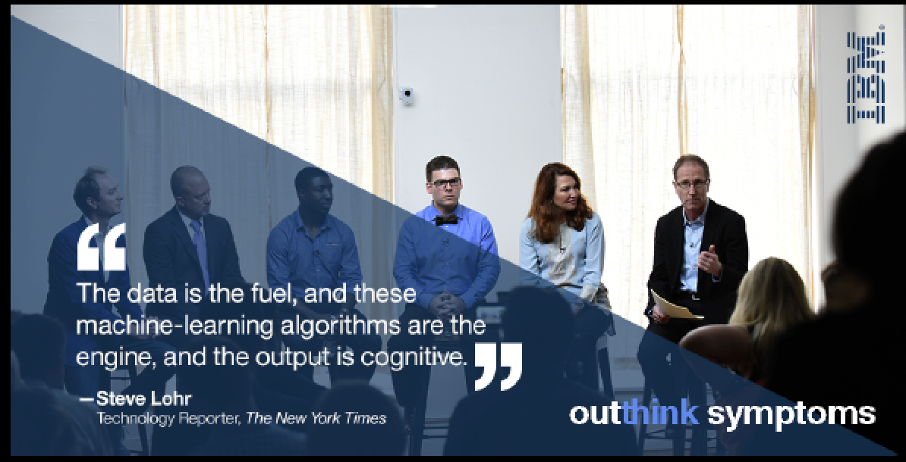

Digital health experts discuss health and technology with NY Times’s
@SteveLohr at this panel: http://ibm.co/2c2A7uP

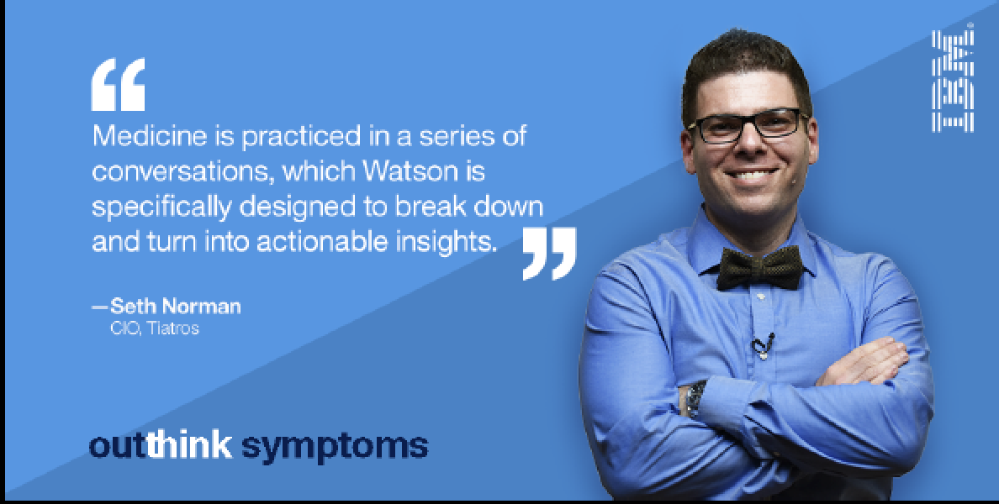

Cognitive tech is advancing mental healthcare. @Tiatros’s CIO @sethrnorman
explains in our panel: http://ibm.co/2bTktkc

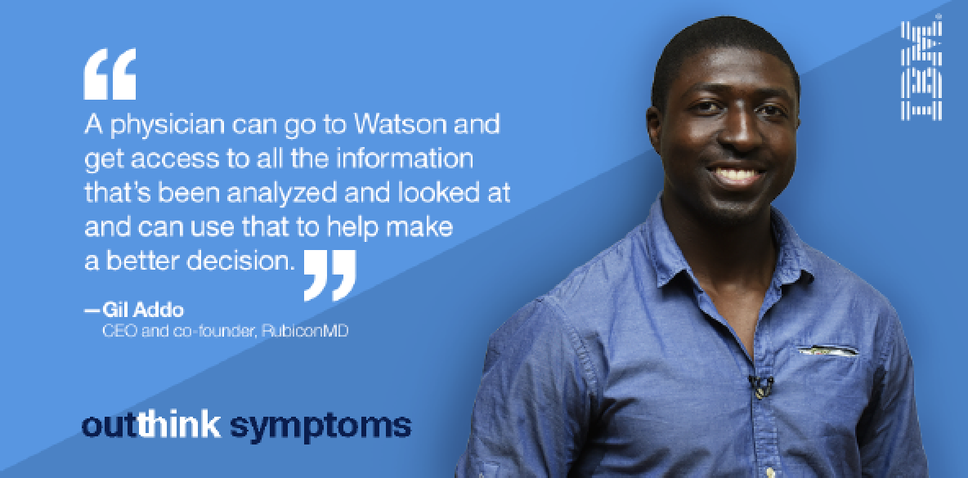

Healthcare tech lets doctors treat more patients, says @Rubicon_MD’s @GilAddo in our panel: http://ibm.co/2cGkUEi

